ASSIGNMENT 5

DOS ATTACK

A single host ,i.e., 172.16.0.107 fires [ACK] packets at a server 74.125.95.147. This can be seen more evidently after typing the filter ip.addr==74.125.95.147.
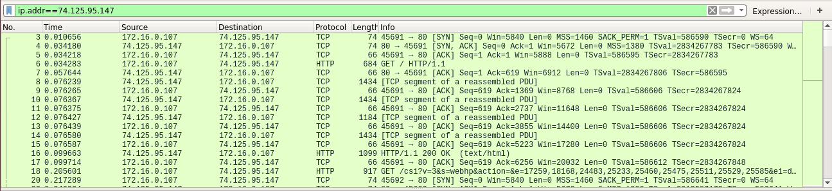
The same host also establishes many DNS connections with another server 12.153.20.41. This increases the traffic to that server also.
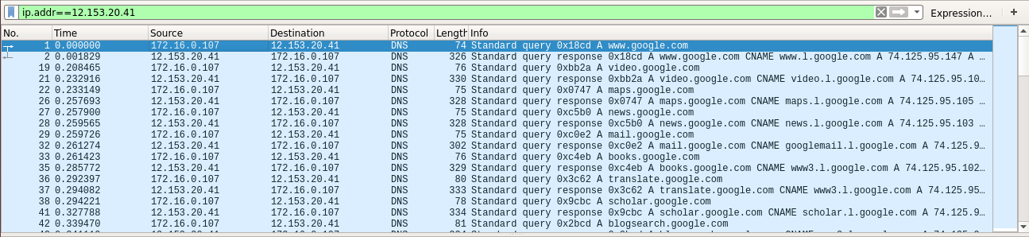
Eventually, the servers will stop accepting legitimate connections. We can examine the number of bytes sent under Statistics -> Conversations.

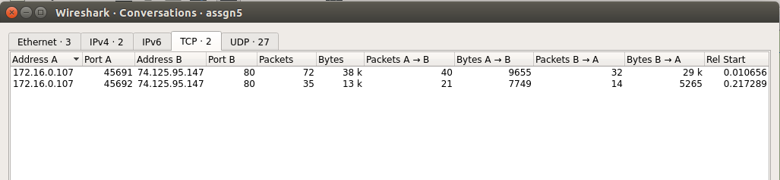

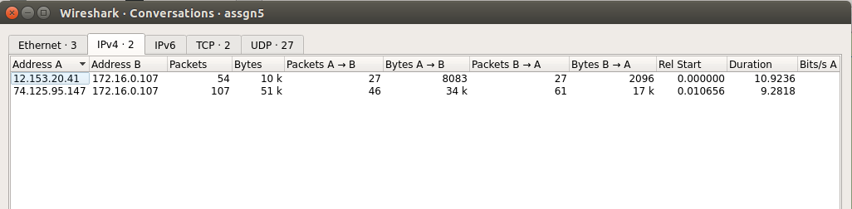

Checking Statistics->Endpoints we get
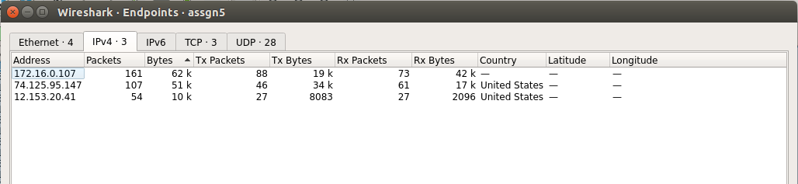
This shows that 172.16.0.107 is the highest talker and causes maximum traffic.

